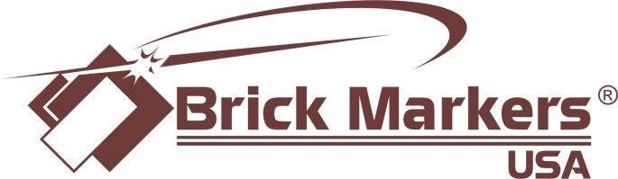
12x12 Multi Options
- 4x8 up to 3 lines and 20 characters per line at  ½” text height or  - 4x8 up to 3 lines and 14 characters per line at ¾” text height | **Custom Logo,  Free Clipart or Free  Lucida Calligraphy  Letter Only (see  clipart library for free  clipart and Lucida letters)
-8x8 up to 6 lines and 20 characters per line at ½” text height or  -8x8 up to 6 lines and 14 characters per line at ¾” text height | - 4x8 up to 3 lines and 20 characters per line at ½” text  height  or  - 4x8 up to 3 lines and 14 characters per line at ¾” text  height  or  - 4x8 up to 1 vertical line and 8 characters per line  at ½” text height

Examples:

Custom Logo Example Free Clipart Example Free Letter Example Free Clipart Example
